French 1001 Online : Autobiographie

Écriture 4—Module 10

Présentation
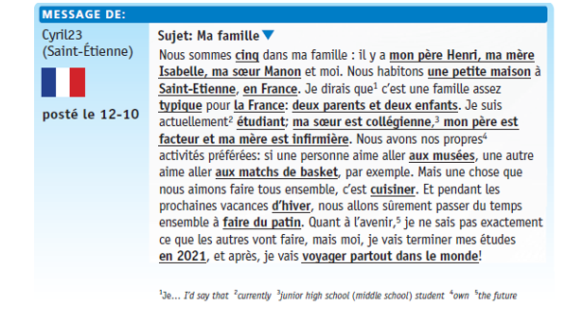
Continue your autobiography by writing a paragraph of at least 125 words in length, using the model provided relating to the content of chapter 3. Replacing the underlined, boldfaced words in the “Forum” with your own autobiographical information will give you a good start, but you should add in details/examples/explanations to expand upon what the models provide and reorganize the content as needed.

Add the following structures:

- An adverb of frequency: parfois, souvent, rarement
- one negative sentence

Write only as much as you can accurately express in French. The autobiography must be typed, double-spaced, and submitted electronically by the due date indicated on Moodle.

***Remember, the use of outside help or resources, including translation software, is not allowed for this, or any other, graded assignment. Any indication of that being the case will result in a score of zero for this assignment.

*Type your paragraphs (double-spaced) in the space below. Make sure to include all necessary accents! Include your name in the name of the file when saving your document. Upload the doc to the Moodle Assignment.

